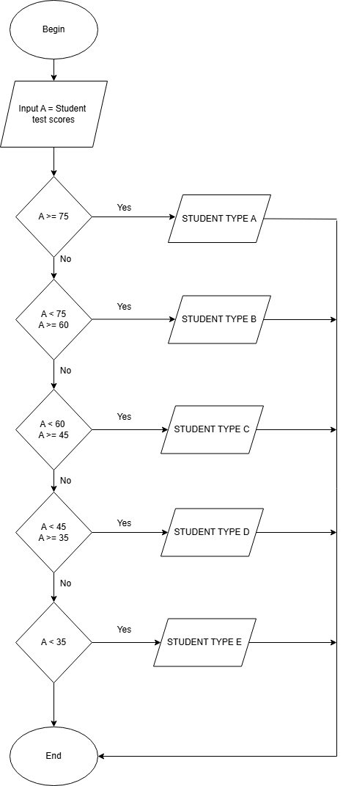

Begin

Input A

IF A >= 75

Print Student Type A

Else

IF A <75

A >= 60

Print Student Type B

End If

End if

IF A < 60

A >= 45

Print Student Type C

Else

If A < 45

A >=35

Print Student Type D

End If

End If

If A < 35

Print Student Type E

End If

END